SECTION IV:

Rating Scales

Chapter 8: Communication Rating Scales
The Communication Rating Scales are to be used as organizational tools after the assessment data of the student’s communication abilities have been completed and interpreted. The tool is designed to enable Speech-Language Pathologists (SLPs) to document assessment findings according to the intensity of those findings and to make a determination of eligibility for a Speech or Language Impairment (SLI) based on those assessment results, in collaboration with the IEP team. The tool is not a diagnostic instrument but a way to organize evaluation findings. The scales must be used with a body of evidence to include formal and/or informal assessment data, educational observations, parent and family input.
The Speech-Language Pathologist will determine whether to use the COMPREHENSIVE ASSESSMENT OR OBSERVATIONAL ASSESSMENT ONLY within the RATING SCALE. Comprehensive Assessment is recommended for the area(s) of concern, unless a standardized assessment is not appropriate due to cognitive, linguistic or cultural reasons. The Comprehensive Assessment considers functional communication skills in relation to the student’s educational environment and provides evidence to support abilities not based solely on a single assessment score.
The following definitions are included to accompany the communication rating scales:
“A language impairment is impaired comprehension and/or use of spoken, written, and/or other symbol systems. The disorder may involve: (1) the form of language (phonology, morphology, syntax); (2) the content of language (semantics); and/or (3) the function of language in communication (pragmatics) in any combination” (ASHA, 1993). A language impairment does not exist when: (1) language performance is appropriate to normal development; (2) language differences are primarily due to environmental, cultural or economic factors including non-standard English and regional dialect; and, (3) language performance does not interfere with educational performance. The three Language Scales are: Receptive Language Scale, Expressive Language Scale, and Pragmatic Language Scale.
Discourse, categorized as conversation, narration, persuasion, and exposition, is defined as higher order language skills used to understand and explain complex concepts beyond the sentence level (Nippold, 2014). This language skill has been added to the receptive and expressive language rating scales as another area to consider during an observation on the student’s functional communication skills in the educational setting. Discourse is a continuum of conversational language to higher order literacy skills reflected in academic content. It takes foundational linguistic skills and applies them to the academic skills of listening, speaking, reading, writing, and thinking. In the educational setting students participate through conversational discourse where they are able to share their ideas and feelings with others; narrative discourse where they are able to recount an event or experience, formulate a story, retell a story without listener prompting; and expository discourse where they need to understand the instructional language of the teacher, text, and classroom discussion.
Auditory Processing and Auditory Perception are included in the Receptive Language Scale since they are part of the eligibility criteria in the Early Childhood Education Act (ECEA 2.08(9)(a)) for Speech or Language Impairment. The role of the speech language pathologist is to determine how the student is processing and perceiving auditory information as related to language development. There is a hierarchical development of auditory processing skills which have individual functions but work together in an integrated system. Areas for consideration are: sensation (acuity), perception (discrimination, sequencing, analysis and synthesis) auditory association and auditory attention. Sensation can be determined through medical/education records, hearing screening or other appropriate sources. Perception, auditory association and auditory memory can be assessed through a variety of formal and informal assessments, parent/teacher report, observation or other appropriate sources.
Some skills commonly associated with auditory processing abilities which could be evaluated by the speech-language pathologist are listed in the table along with a brief definition and some examples (Keith, 2004).
Table 1: Auditory processing and auditory perception skills
Auditory Processing Skills | Definition | Examples
Sensation (acuity) | The ability to hear sounds | Audiogram. Educational/medical report
Auditory discrimination | The ability to discriminate between phonemic elements of speech that are acoustically similar (sun/fun). | Minimal pairs, same or different word lists, CTOPP, TAPS, TOLD-4
Auditory sequencing | The ability to recall the order of a series of details. | Recalling numbers, words, syllables, details of a story in sequence,
Auditory attention | To direct attention to relevant acoustic signals, specifically speech or linguist stimuli, and sustain that attention for an appropriate amount of time. | Following directions in class, filtering background noise to attend to teacher, TAPS, CTOPP
Auditory synthesis | The ability to merge or blend isolated phonemes into words. Auditory synthesis is critical to the reading process.(/t/a/p/ = tap) | Blending words from sounds, making compound words, CTOPP, TAPS
Auditory analysis | The ability to identify phonemes or morphemes embedded in words as seen in verb tense (e.g., worked vs. works) and other morphological markers. | Making 2 words from compound words, taking words apart by their sounds, CTOPP, TOLD-4
Auditory association | The ability to attach meaning from an acoustic signal and associate it to its source or label, such as non-linguistic sounds or words. | Words that go together, matching sounds to pictures, Word Classes
Auditory memory | The ability to store and recall auditory stimuli in the appropriate order or sequence (e.g., following directions, retelling a sequential story in order). | Following novel directions, recalling details from a story read aloud, TAPS
(Adapted from the chart on page 125 by Robert Keith)
If there are concerns with the auditory system which warrant further assessment to determine Auditory Processing Disorder (APD or (C)APD), the speech-language pathologist should consult with an audiologist. Speech language pathologists do not diagnose (C)APD. A diagnosis of Auditory Processing Disorder does not automatically make a student eligible for special education services. For further information please consult the technical assistance document on The Consideration of Clinical Diagnoses in the Educational Identification of Disabilities in Accordance with IDEA 2004.
An articulation impairment is the “atypical production of speech sounds…that may interfere with intelligibility” (ASHA, 1993). Errors in sound production are generally classified as motor-based or cognitive/linguistic-based (Bernthal and Bankson, 1988). Motor-based errors are generally called articulation impairments; cognitive/linguistic-based errors are referred to as impairments of phonological processes. While some practitioners classify phonological process errors as language impairments, for purposes of these guidelines they are included, along with articulation impairments under the category of phonology. An articulation impairment does not exist when: (1) sound errors are consistent with normal articulation development; (2) articulation differences are due primarily to unfamiliarity with the English language, dialectal differences, temporary physical disabilities or environmental, cultural or economic factors; or, (3) the errors do not interfere with educational performance resulting in a denial of FAPE.
A fluency impairment includes stuttering, cluttering and other speech related disorders. “A fluency disorder is an interruption in the flow of speaking characterized by atypical rate, rhythm, and repetitions in sounds, syllables, words, and phrases. This may be accompanied by excessive tension, struggle behavior, and secondary mannerisms (ASHA, 1993).” A fluency impairment does not exist when (1) disfluent behaviors are part of normal speech development and/or (2) disfluent behaviors do not interfere with educational performance resulting in a denial of FAPE. In the standardized assessment component of the rating scale for Fluency standard deviation can be either above or below the mean depending on the assessment being used. When using a standardized assessment that doesn’t fit the typical mean score with normal distribution (mean = 100, SD = 15), use guidance from the assessment manual to determine the appropriate rating. For example, in the OASES, a rating of Moderate-to-Severe is .5-1.49 SD above the mean, which would relate to a score of 3 or 4 on the rating scale. Other instruments may report scores descriptively, in which case a score of Mild = 2 on the rating scale, Moderate = 3, Severe = 4.
A voice impairment is the abnormal production and/or absence of vocal quality, pitch, loudness, resonance, and/or duration which is inappropriate for an individual’s age and/or gender (ASHA, 1993). A voice impairment does not exist when vocal characteristics: (1) are the result of temporary physical factors, such as allergies, colds, enlarged tonsils and/or adenoids, or short term vocal misuse or abuse; (2) are the result of regional, dialectic or cultural differences; and/or, (3) do not interfere with educational performance resulting in a denial of FAPE. The American Speech-Language-Hearing Association (ASHA) recommends that individuals receive a medical examination and medical clearance from contraindicating physical problems prior to participating in voice therapy. Consideration should be given to the policies and procedures within an AU, if medical clearance is required in order to determine eligibility for special education. SLPs should consult with their local administration for policies and procedures regarding the evaluation and treatment of voice disorders.

Using the SLI Guidelines with Children Evaluated and Served under Part C
Based on S.B. 07-255, Child Find Responsibilities under IDEA, AUs are responsible for determining significant developmental delay for children under the age of three based on the definition within the Early Intervention Colorado State Plan under Part C of the Individuals with Disabilities Education Act. The determination of significant developmental delay is based on either an equivalence of 25% or greater delay in one or more areas of development (adaptive, cognitive, communication, physical, including vision and hearing, and social emotional) when compared with chronological age or the equivalence of 1.5 standard deviations or more below the mean in one or more areas of development. It is the responsibility of the local Community Centered Board personnel to determine a child’s eligibility for Part C services based on the findings of the child find team’s evaluation information. To access more information on Child Find click on the following link Child Find website for children birth to 5 years.

Procedures for scoring the Communication Rating Scales
The information in this section is for use with students served under IDEA Part B (3-21 Years), although some of the rating scales may be used for children served under IDEA Part C (birth-3).
- Use the Communication Rating Scales to rate the student’s communication in each area of concern. For each Communication Rating Scale completed, it is necessary to check the appropriate scores in each component within that scale. For example, if you are completing the Articulation /Phonology Rating Scale, Normative Assessment (if used), Observational Assessment; Consistency, Stimulability, and Self-correction; Oral Motor Structure and Function; and Adverse Effect on Educational Performance components must be scored. If using a standardized assessment, use the overall score of the assessment or composite score or index. Do not use a subtest or individual test within an assessment to score this component. The component scores are all weighted according to their importance within in each rating scale. If one subtest or test within an assessment is significantly lower, compare or observe these skills in the educational environment when scoring the observational section. Do not alter the weighted scores. For example, do not score Consistency, Stimulability and Self-Correction as a “2.5”. No zeros (0) are to be used on these scales.
- The following Communication Rating Scales are designed to be used for students who are served under IDEA Part B (3-21 years):
  - Receptive Language Rating Scale
  - Expressive Language Rating Scale
  - Pragmatic Rating Scale
  - Articulation/Phonology Rating Scale
  - Fluency Rating Scale
  - Voice Rating Scale
- For each Communication Rating Scale, all of the component ratings should be summed to determine the total score.
- The total score for each Communication Rating Scale corresponds to one of the following ratings. Be sure to use the appropriate rating (either Part B or Part C). The rating is then used to guide determination of eligibility for speech-language services.
Part B students Part C children
Rating of 1 = 1 (Within Normal Limits) 1 (Within Normal Limits)
Rating of 2 = 2 (Mild) 2 (Mild Delay)
Rating of 3 = 3 (Moderate) 3 (Significant Delay)
Rating of 4 = 4 (Severe) 4 (Significant Delay)
Under Part B, students with overall ratings of 3 or 4 may be eligible for speech or language services. The model of service delivery should be based on the needs of the student, ensuring the least restrictive environment, access to the general education curriculum and/or appropriate age-related activities, and reasonable educational benefit from services, as discussed at the IEP meeting. Consult individual Administrative Units (AUs) for additional guidance regarding eligibility for services for students.

Using Scales with students who are Culturally, Linguistically Diverse
Use the Observational Rating Scale and do not report normative standard scores with a student who is culturally-linguistically diverse (CLD) unless assessments used are standardized with normative samples that match the demographic background of the student. See Section III: Assessment Considerations for English Learners of the Colorado Speech or Language Impairment Guidelines for Assessment and Eligibility for further information on assessing culturally and linguistically diverse students.

Variance in Determining the Rating
For each Communication Rating Scale, the SLP determines the Rating based on the Total Score (Figure 1).
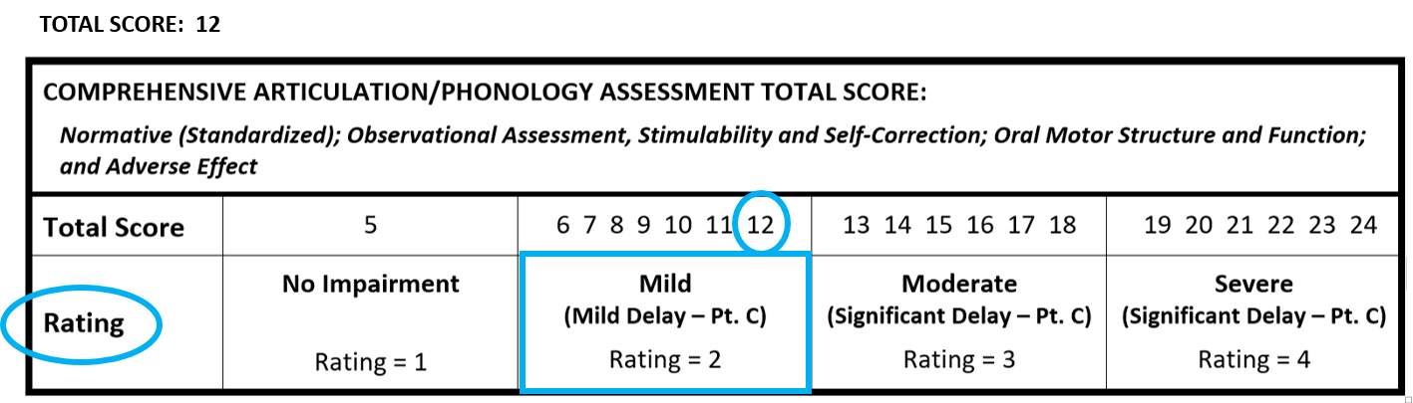
[Figure 1]

At the eligibility meeting, the SLP, in collaboration with the IEP team, may consider the following information: student attendance, cognition, rate of progress, response to interventions, cultural, economic, and linguistic differences, or other factors to add or subtract one point to/from the Total Score, not the Rating. The use of the variance should be considered only during the eligibility meeting if the addition or subtraction of a point would shift the student to another Rating. For example, if the student has a total score of 12 on the Articulation/Phonology Rating Scale, the student would receive a Rating of 2 (Mild for Part B) (Figure 2).
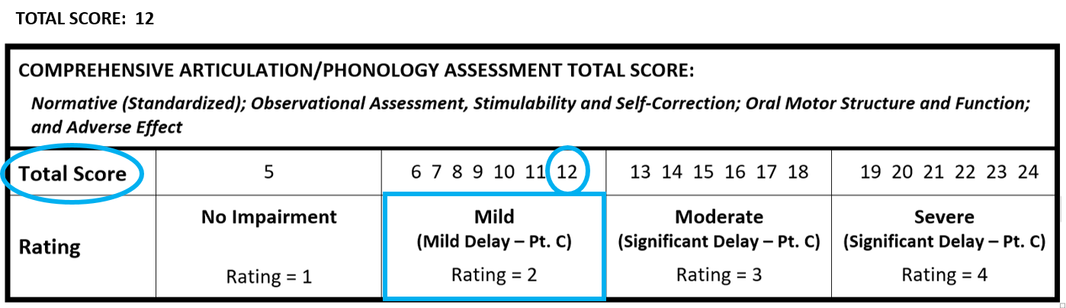
[Figure 2]

Suppose the IEP team, due to other factors supported by documentation, determines that the score is not reflective of the student’s needs. They can add a point to the score making it 13 (Figure 3), which would correspond to a Rating of 3 (Moderate for Part B). IEP team discussion and any changes in the Rating must be documented within the IEP (for example, in ‘Student Needs and Impact of Disability’) and in the Prior Written Notice, if these scores are reported in the eligibility or IEP paperwork.

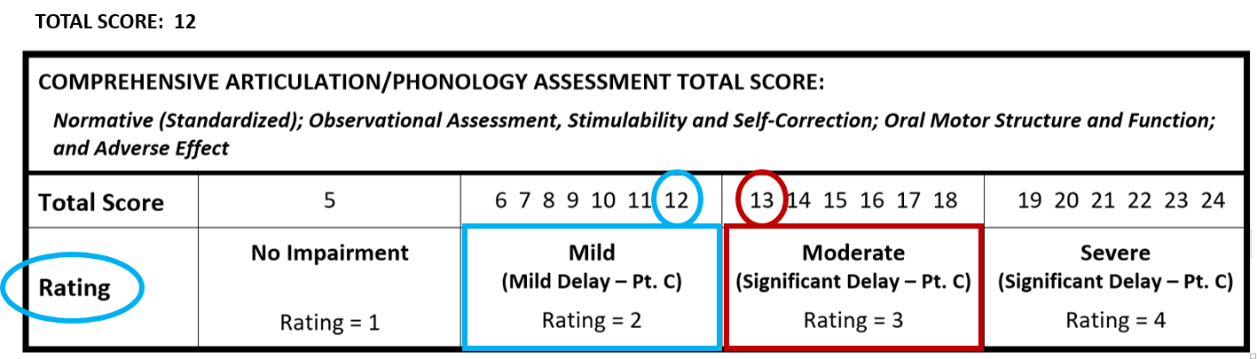
[Figure 3]

Articulation/PHONOLOGY Rating Scale

STUDENT: SLP: DATE:

Normative Assessment of Articulation/Phonology:  Comprehensive, standardized measure(s) and scores.  Consider appropriateness for CLD students throughout scale | SCORE = 1  <1 standard deviation from the mean  for example:  Standard Score (SS) ≥85 when the mean is 100 and the standard deviation is 15 | SCORE = 2  >1.0 - 1.5 standard deviations from the mean  for example:  Standard Score (SS) = 84 -78 when the mean is 100 and the standard deviation is 15 | SCORE = 3  >1.5 – 2.0 standard deviations from the mean  for example:  Standard Score (SS) = 77-70 when the mean is 100 and the standard deviation is 15 | SCORE = 4  >2.0 standard deviations from the mean  for example:  Standard Score (SS) = 69 or below when the mean is 100 and the standard deviation is 15
Observational Assessment of Articulation/Phonology:  Check descriptive tool used:  __ Speech sample  __ Checklist(s)  __ Observations  __ Other _______________  The lists are possible suggestions and are NOT intended to be all-inclusive lists. | 1  All of the following are adequate for speech production.  Production of speech is Within Normal Limits in all educational settings including early childhood environments.  Errors, if present, are consistent with normal development | 2  Speech production is characterized by the following.  Speech sound errors are present and may be non-developmental  Intelligibility occasionally results in communication breakdown | 3  Two are present  Intelligibility often results in communication breakdown due to sound productions noticeable in error  Unresolved phonological patterns, typical or idiosyncratic  Articulation errors including (substitutions, omissions, distortions and additions) which are not found in age-matched peers who are culturally and linguistically similar  Vowel Errors  Compensatory speech patterns/ Idiosyncratic Errors | 4  Three are present  Intelligibility consistently results in communication breakdown due to sound productions extensive in error  Unresolved phonological patterns, typical or idiosyncratic.  Articulation errors including (substitutions, omissions, distortions and additions) which are not found in age-matched peers who are culturally and linguistically similar  Vowel Errors  Compensatory speech patterns /Idiosyncratic Errors

Articulation/PHONOLOGY Rating Scale

STUDENT: SLP: DATE:

Consistency, Stimulability and Self-correction:  Judgments are based on the student’s performance as compared to developmental, dialectic, cultural and linguistic expectations.  NOTE: Ability to self-correct should NOT be considered for children ages 0 THROUGH 3. | 1  Both are checked  Consistent sound patterns  Stimulable for all sounds within the developmental norms. | 2  At least two are checked  Minor inconsistencies in sound production  Stimulable for error sound/s in at least one context within the developmental norms.  Frequent self-corrections noted. | 3  At least two are checked  Frequent inconsistencies in sound production  Limited stimulability for error sound/s within the developmental norms.  Inconsistent self-correction | 4  At least two are checked  Consistent error patterns  Not stimulable for error sound/s within the developmental norms.  No self-corrections noted.
Oral Motor Structure and Function: | 1  Oral structures appear normal and adequate for speech production. | 2  Mild difficulties in oral motor and/or sequencing do not interfere with speech production. | 3  Moderate difficulties in timing, sequencing and/or coordination of speech sound/s are evident. | 4  Severe difficulties in timing, sequencing and/or coordination of speech sound/s are evident. Additional neuro-motor and/or structural deficits may be present.
Adverse Effect on Educational Performance: | 1  Speech is adequate for the student’s participation in all age-appropriate educational settings including early childhood environments. | 4  Speech sounds are developing. Speech errors mildly impact the student’s participation in all age-appropriate educational settings including early childhood environments. | 6  Speech errors moderately impact student’s participation in all age-appropriate educational settings including early childhood environments. | 8  Speech errors severely impact student’s participation in all age-appropriate educational settings including early childhood environments.

ARTICULATION/PHONOLOGY RATING SCALE

STUDENT: SLP: DATE:

Instructions:
- Check the box for the most appropriate description for each component: Normative (Standardized), Observational (Descriptive), Consistency, Stimulability and Self-Correction/ Oral Motor Structure and Function, and Adverse Effect.
- Compute the total score.
- Circle below to determine the Rating.

TOTAL SCORE:

COMPREHENSIVE ARTICULATION/PHONOLOGY ASSESSMENT TOTAL SCORE:
Normative (Standardized); Observational Assessment, Stimulability and Self-Correction; Oral Motor Structure and Function; and Adverse Effect
Total Score | 5 | 6 7 8 9 10 11 12 | 13 14 15 16 17 18 | 19 20 21 22 23 24
Rating | No Impairment  Rating = 1 | Mild  (Mild Delay – Pt. C)  Rating = 2 | Moderate  (Significant Delay – Pt. C)  Rating = 3 | Severe  (Significant Delay – Pt. C)  Rating = 4

OR

OBSERVATIONAL ASSESSMENT ONLY – ARTICULATION/PHONOLOGY ASSESSMENT TOTAL SCORE:
Observational Assessment; Consistency, Stimulability and Self-Correction; Oral Motor Structure and Function; and Adverse Effect
Total Score | 4 | 5 6 7 8 9 10 11 | 12 13 14 15 | 16 17 18 19 20
Rating | No Impairment  Rating = 1 | Mild  (Mild Delay – Pt. C)  Rating = 2 | Moderate  (Significant Delay – Pt. C)  Rating = 3 | Severe  (Significant Delay – Pt. C)  Rating = 4

Final determination of disability is made by the Multidisciplinary Team.

