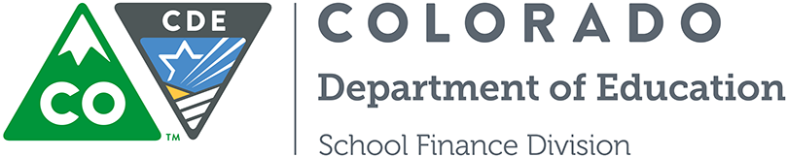

Ongoing Administrative Review of State Board of Education Rules

- Question or Issue:
Pursuant to Section 24-4-103.3, C.R.S., each state agency is required to establish a schedule for the review of all of its existing rules. The purpose of that review is to assess the continuing need for and the appropriateness and cost-effectiveness of the agency’s rules to determine if they should be continued in their current form, modified, or repealed.

Policy for Review of State Board Rules establishes a protocol for the Colorado Department of Education to follow in reviewing the Board’s existing rules and to make recommendations to the Board concerning its findings. A schedule for the ongoing review of the rules and supporting templates are included.

Currently, the department is soliciting input on the following rules: 1 CCR 301-4 Determination of Indigency and Establishing Policy on School Fees and 1 CCR 301-14 Rules for the Administration of the Public School Transportation Fund.

Comments may be submitted to RuleReview@cde.state.co.us using the Template for Public Comment on CDE's Administrative Rule Review.

- Any Prior FPP Action:

- Discussion Points/Department Recommendation or Observations (if any):

- FPP Action, Decision Made:

- Further Action/Research Needed/Table for Future Meeting:

- Effective Date:

