Local Access Manager (LAM) Instructions for Accessing GAINS
CDE uses Identity Management to streamline the user login process for CDE data systems and enhances security to student-level data. It automates the user registration, approval, and password reset processes and provides districts and administrative units with the ability to maintain users via a Delegated Administration model.

District LAMs will be assigned the role of User Access Administrator and can add and assign roles to district staff members. This process will ensure that those who are authorized to complete grant applications on behalf of the district have access to the grant application system.

To access GAINS:
1. Visit https://colorado.egrantsmanagement.com/. Click on the GAINS Sign-In icon in the upper right side of the screen.
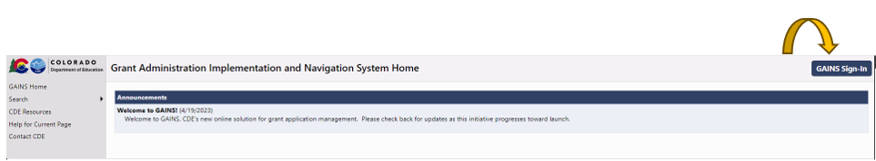

2. Click on the Sign in with CDE Identity Management (IdM) button.
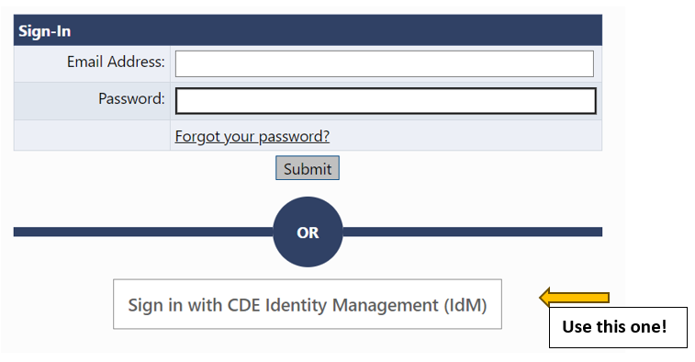

3. The next page you will see is where you enter your Single Sign-on credentials. Your username will be your full organization email. Your password will align to other CDE logins like the Consolidated Application, ESSER, and/or the UIP System.
Once you are logged in, you will be able to see your organization’s profile and associated applications.

Creating New Users
Note: Only create new users for people who have never had access to the system.

- Hover over Administer on the left navigation menu, select User Access. (This menu item only appears for persons with the User Access Administrator role.)
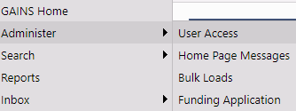

- The User Access page provides the ability to search for existing users using several filters – last name, role, organization. Please be sure to search for the individual first before creating a user. If the user already exists, jump to the Modifying and Removing Users section of this guide.
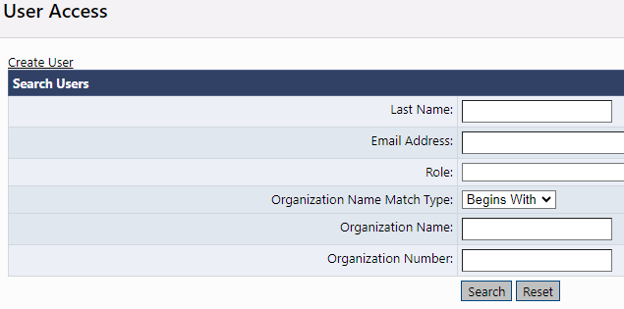
- Click on the “Create User” link to open a screen to create a new user.

- Enter the email address, first name and last name. It is advisable to add a phone number if it is known. However, the user can add it later from the user profile. Click on “Create.” The system sends an email to the address permitting the new user to set a password. Since users are going through IdM, please have the new user ignore this email.

- The system next displays the Administer Roles page. All new users will appear to not have any roles assigned. The users will be able to login into the system but unable to access any information until a role is created. Click on Create Role.
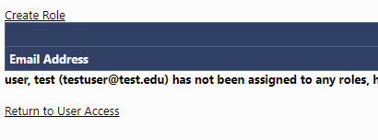
- LEA User Access Administrators can only create roles for their own organization. Select a role or roles for the user using the drop-down box and click on the Create button. Note: for Grant application users, leave the school selection at “ALL.”
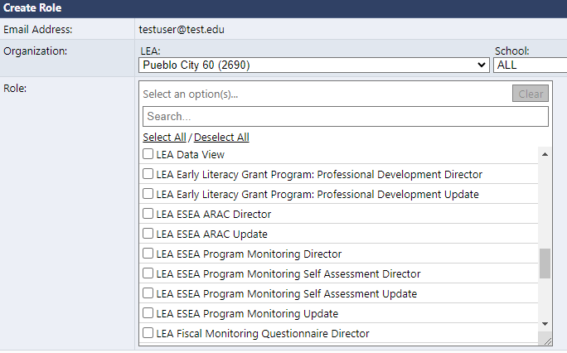

- As a reminder, new users are sent an email from “GAINS.NoReply@eGrantsManagement.com” as soon as they are added to the system. This email allows them to set their own password. Since users are going through IdM, please have the new user ignore this email.
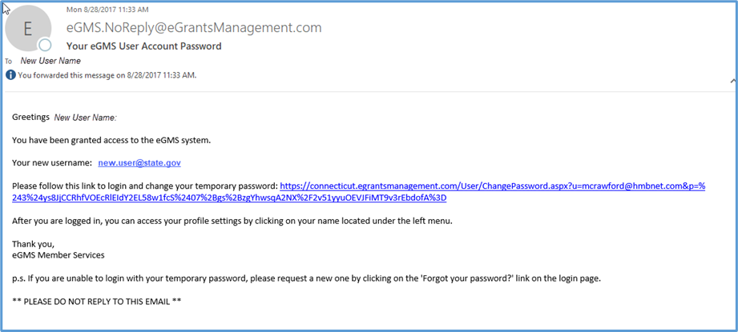

Modifying and Removing Users
- Changing roles
  - To change, delete or add a new role for an existing user, search for the user from the User Access screen.
  - Click on the Administer Roles icon.
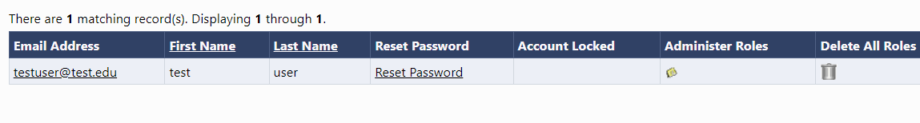
  - From the Administer Role screen, you can add a new role by clicking on “Create Role” or delete an existing role by clicking on the trashcan icon beside the unwanted role.
- Deleting a User
- Users cannot be deleted from the system to preserve the integrity of audit records. However, by deleting all roles, they no longer have access to any funding applications. Click on the “Delete All Roles” trashcan icon to disable a user.
- Updating a profile
- Users can update their own profiles once they are logged into the system. However, a user access administrator can also modify the profile by searching for the user and clicking on the user email address from the search results.
- Managing Passwords
- If users forget their password or want to reset their password, they can use the Forgot your password link. Please note that changing the IdM password for GAINS will change the password for other CDE logins as mentioned above (Consolidated Application, ESSER, the UIP System).
- User Roles
There are several roles that will be available to use when providing access to district users. The list below contains the role and the definition/access the user will have once assigned to the role. User Access Administrators can provide users with access to all grants in the system or, as grants are created, assign users to specific grants.

Please keep in mind the following aspects of User Roles:
- A role grants a set of permissions,
- A user can have more than one role,
- A role can be assigned to more than one user,
- And, every LEA Organization MUST have an LEA Fiscal Representative and LEA Authorized Representative to submit applications and create fund requests.

For ALL Applications in the LEA

Role | Access
LEA Data View | Has the authority to view all organization content but no editing or status changes.
LEA Fiscal Representative | The Fiscal Representative is authorized to approve grants, complete, and submit requests for funds, and will receive fiscal related communication regarding the application. Usually the organization Fiscal Manager, but other personnel can also have this role in your budgeting office.
LEA Authorized Representative | The Authorized Representative is authorized to provide final organization approval and submit the application to CDE on the applicant's behalf. Can be a superintendent, CFO, CEO, and/or anyone else at the organization who has authority to approve an application.
User Access Administrator | Has the authority to manage LEA user roles. The district LAM(s) has this role by default, but it can be assigned to others in the organization.
LEA All Funding Applications Update | Authorized to edit/update drafts of any grant application for which the organization is eligible but cannot change statuses/approve. Could be a district grant manager or grant writer.
LEA All Funding Applications Director | Authorized to create and complete drafts of any grant application for which the organization is eligible. Can change status of application to “Draft Complete” but cannot approve. Could be a grant manager or grant writer.

Additional roles automatically get created as applications are added to the system. When an application is created, the following roles may be created. User Access Administrators can assign users to specific applications.

For SPECIFIC Applications in the LEA
Role | Access
LEA [Funding Application Name]* Update | Authorized to edit/update application draft of the named grant but cannot change statuses. Could be a school-based staff member or external consultant who will need to assist in editing a grant application but would not have authority to finalize a draft.
LEA [Funding Application Name]* Director | Authorized to create and complete application draft of the named grant but cannot approve. The specific person managing the grant if this is not a centralized role for your district.
*Replace “[Funding Application Name]” with a grant name. For example, LEA Student Wellness Grant Update or LEA Student Wellness Grant Director.

If you have any issues with logging into the system, please reach out to us at GAINS@cde.state.co.us.

