ReAsons not TESTED (special Circumstances Codes)
In the event that a student cannot participate in any testlets to generate a performance level used for federal and state accountability, DLM provides a way to record a Special Circumstance Code in Educator Portal, providing the reason the student was not tested, e.g., medical event.
The Special Circumstances fields are located on the same screen where a teacher finds the Test Information Pages (TIPs): the test session browser under Test Management. The fields are visible only to those who have BTC, DTC, or SAA roles in KITE Educator Portal. A teacher will neither be able to enter a code nor even see the Special Circumstances Code fields. The Special Circumstances field is a drop-down window. The codes are descriptive words, e.g., Medical Waiver or Parent Refusal. These codes are not available unless the student has a test ticket generated. If students do not have test tickets codes must be applied during SBD.
After the BTC, DTC, or SAA selects the code in the dropdown menu, at the bottom right corner of the screen, the SAVE button must be clicked. In most scenarios, the code is entered once per content area associated with the first testlet auto-enrolled in Educator Portal. However, in certain cases, a Special Circumstance Code may need to be entered on a later testlet, such as a misadministration.
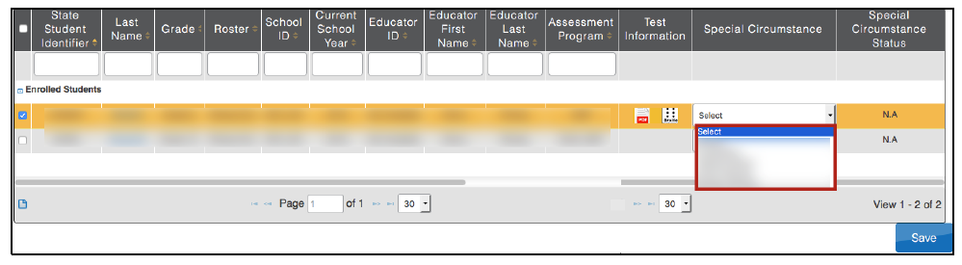
The following table gives the Colorado invalidation definitions associated with each option in the drop down menu. In all reporting and participation calculations the invalidations will be interpreted according to the Colorado definition rather than the dropdown label.

Text Label in EP Special Circumstance Dropdown | Colorado Definition
Medical Waiver | Medical Exemption
Home Schooled For Assessed Subjects | Part Time Public and Part Time Home School Student
Special Treatment Center | District Education Services
Parent Refusal | Parent Refusal
Homebound | District Education Services
Student Refusal | Student Refusal
Other Reason For Nonparticipation | Took General Assessment
Left Testing | Interrupted or Not Completed
Teacher Cheating or Mis-admin (CDE is working with DLM to change this language for 2017) | Misadministration or Non-approved Accommodation
Other | Withdrew Before Completion

