Instructions for Removing Students from the District in KITE Educator Portal

Data Steward

Removing a student from the district

The Test, Exit and Clear (TEC) File allows students to be unenrolled from a district.

1. Download the template from the dynamiclearningmaps.org/colorado.



1. Open the file in EXCEL or similar program.



1. Use a new row for each student and complete the information.

(Note: if the school and district code begin with a “0” the cell will need to be a “text” field so the “0” stays.)



1. 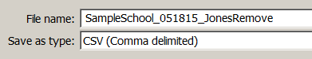Save As a CSV file.
2. **Sign in to Educator Portal.**
3. Select the Configuration tab.



1. Select the Students tab.

Remember in KITE Educator Portal the active tab is white.



1. Select Upload TEC from the drop-down menu.



1. **Complete the fields from the drop-down menus.**

Selecting the CSV icon will allow for a search of the saved file from step 4.



1. Select Upload. 
2. 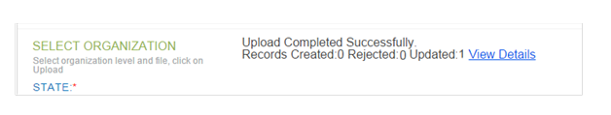Verify that the correct number of records was updated.