Overview
CMAS Site Readiness Infrastructure Trials
CDE Assessment Unit
The CMAS Site Readiness Infrastructure Trial provides a way to test your online assessment environment to verify that your network, proctor caching devices, and student testing devices are configured correctly using Colorado-specific item types. Pearson has created a site readiness form that contains a variety of simulations and technology enhanced items that can be administered through the Colorado Training PearsonAccess ^{next} site. Since the items are pulled together from across grade levels and disciplines, this form should not be used by students.
You may scale the trial any way you choose. You can run the form on specific student testing devices to see how the items behave, or set up a more life-like simulation in a classroom or lab to see how the larger test items impact your network and proctor caching device. If your school or district experienced difficulty with the CMAS Science and Social Studies administration in the past, we recommend you use this tool to help identify any issues you may encounter.
This document assumes you have completed the TestNav Configuration in the PearsonAccess^{next} Training site.
If you have any questions about this form, contact Collin Bonner, Bonner_C@cde.state.co.us

Enter CMAS Training Center in PA next
Go to https://trng-co.pearsonaccessnext.com/
- Select > Site Readiness > CMAS
- Select School or District

Create Students
From Setup > Students, open the task list and select Generate Sample Students. Click Start. | 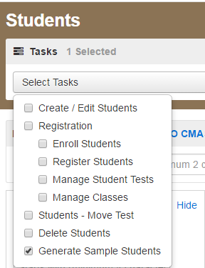
Select Organization  Create New Class: New Class Name (Remember this name for session creation)  Select Grade  Test: Infrastructure Test  Type: Online  Number of Students: up to 99  Select Generate  View Success Message  Select Exit Task | 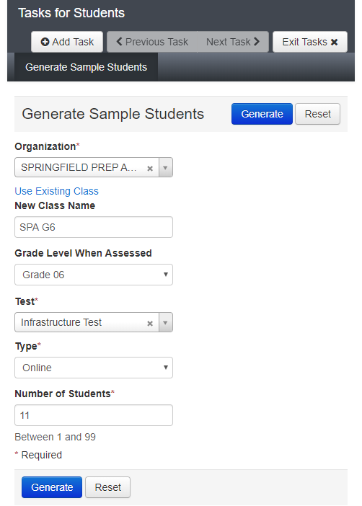

Create an Online Test Session
Complete Details with Create / Edit Test Session Tasks
From Testing > Sessions, click the Select Tasks drop-down and select Create / Edit Test Sessions. Click Start. | 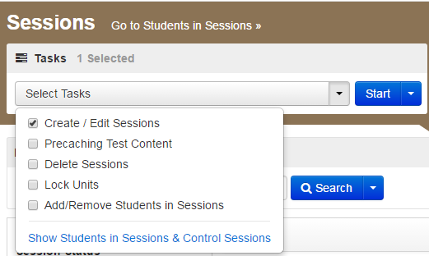
On the Create Session screen complete:  - Session Name  - Test Assigned: Infrastructure Test  - Form Group Type: Main  - Pre-caching Computer  - Organization  - Scheduled Start Date (today)  - Find by Class- Look for the name used when the students were created.  Select Create  View Success Message  Select Exit Task | 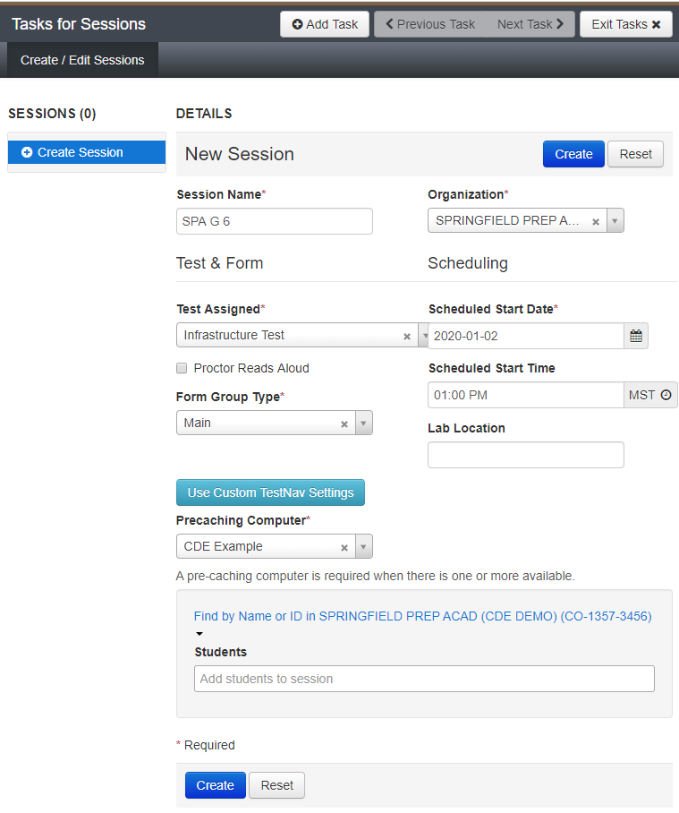

Precache Test Content
Precache Test Content by Test
From Setup > Precache by Test | 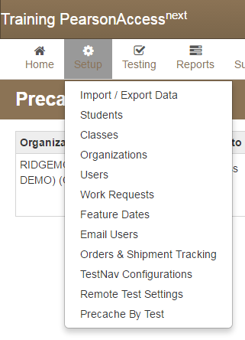
Select one Precache Server from the list and, mark the boxes to select Infrastructure Test.  Click Precache. | 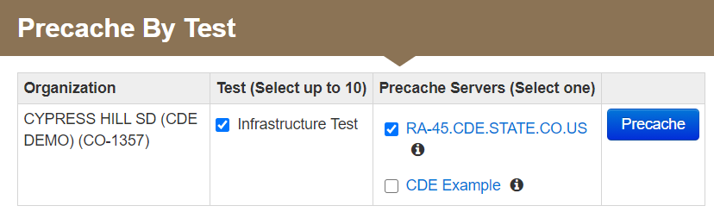
Watch for your browser blocking Pearson’s Precache script.  In Chrome look for the shield in the top right-hand corner of the window  Select Load Unsafe Scripts | 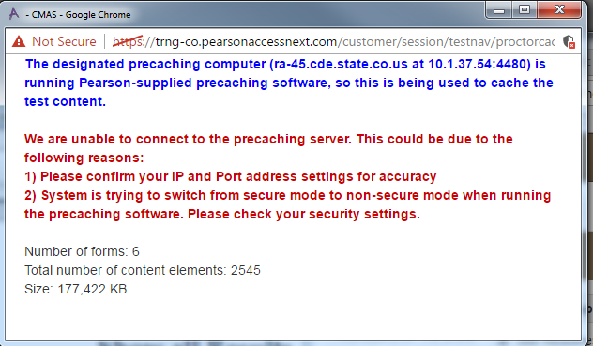
Click Precache. | 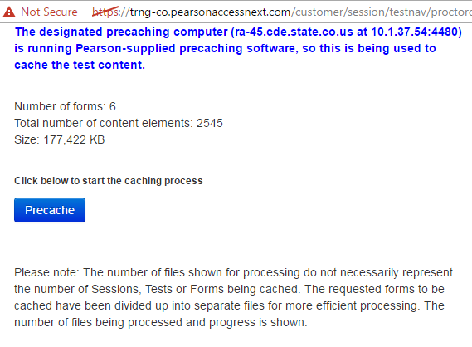

Retrieve Student Test Tickets
From Testing > Students in Sessions, click Add a Session. Search for a session(s) and click Add Selected.  Click Refresh to update the data displayed.  Click a session to select it from the list. If you have trouble finding your session, go to Testing > Sessions, and select the test session(s) that contain the students whose statuses you want to view. To see the listed session(s), return to Students in Sessions. | 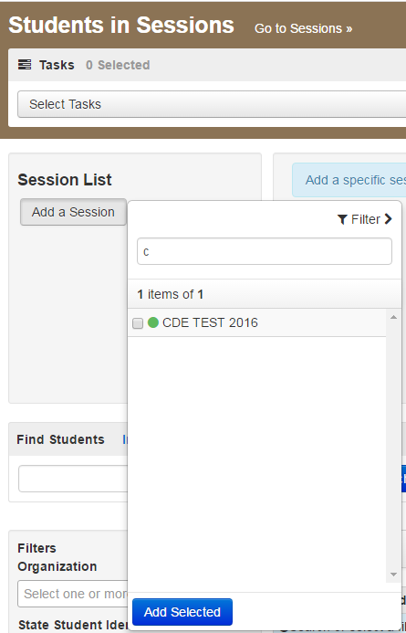
Click the Resources drop-down and from the Student Testing Tickets select either of the following:  Print all for this session to print testing tickets for all the students within the session.  Print selected for this session to print testing tickets for selected student(s) within the session.  Select a student(s) registered in the session, and then click Resources > Student Testing Tickets > Print selected for this session. | 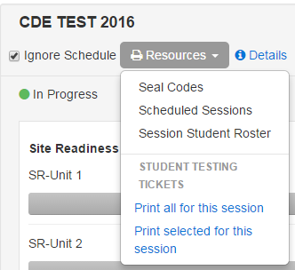
To print, select a print format and then print the testing ticket(s). You can select one of the following:  - 1 Per Page: One student test ticket per page Default selected print format  - 4 Per Page: Four students testing tickets per page  - Grid - All testing tickets print in a grid  - List - All testing tickets print in a list  Print test ticket using your browser. | 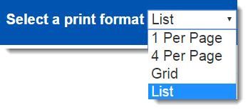

Prepare an Online Test Session
You can prepare sessions two ways:  Prepare a single session:  - From Testing > Students in Sessions, select a session from the Session List and click Prepare Session. | 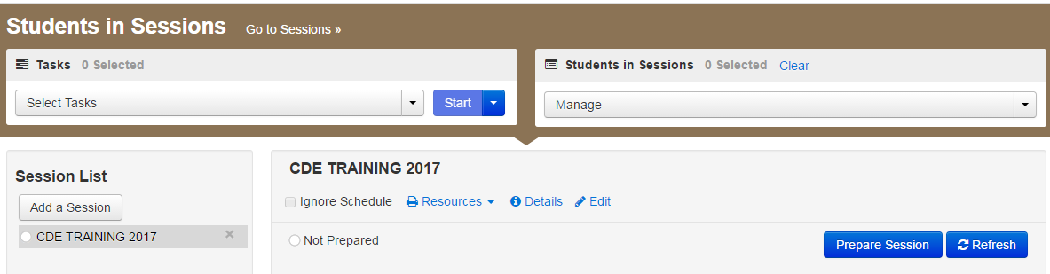
Prepare multiple sessions:  - From Testing > Students in Sessions, select multiple session using the combined view and click Prepare All Sessions. | 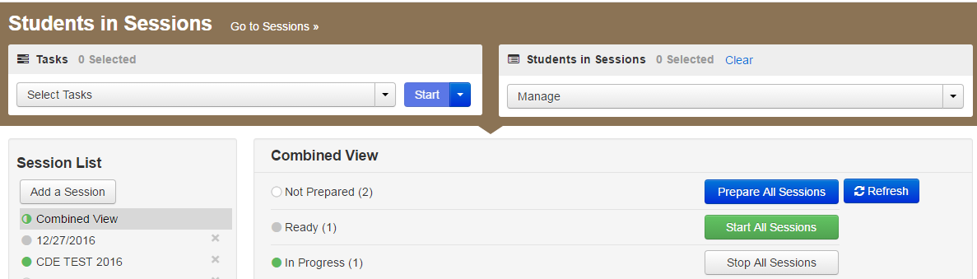

Start an Online Test Session and Unlock the Students Tests
To start a session:  From Testing > Students in Sessions, select a session from the Session List and click Start Session. | 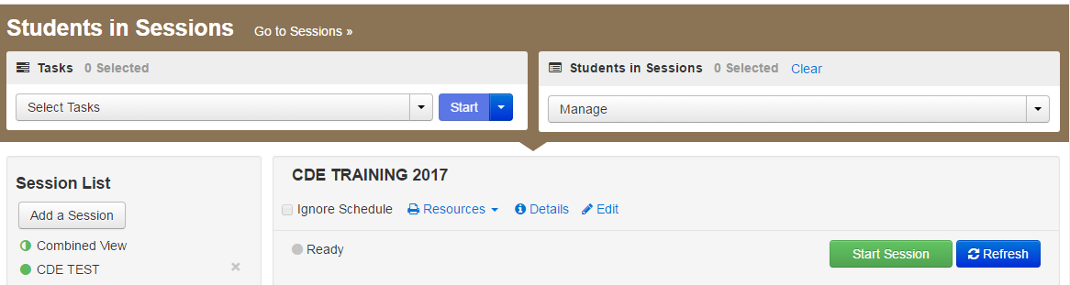
To unlock a test/section for a student(s), follow these steps:  - From Testing > Students in Sessions, select a session from the Session List.  - Click Start Session, or select an In Progress session.  - Select a student with Ready status. Click the drop-down arrow on the status button and select Unlock. | 