Priority Improvement and Turnaround

UIP Support Information Packet (supported by [slide deck](https://docs.google.com/presentation/d/1huelzH5HqFuZ2S1Q2wrtvvKmoYhubyffGEuiBJssb2o/edit?usp=sharing) & recorded webinar)

|  |  |
| --- | --- |
| **Contents of this Packet** | **Key Resources** |
| Performance Watch  Annual Stakeholder Engagement - Process Expectations  Later on the Clock Requirements  Year 3 – Community Meeting  Year 4 – Identify Pathway Preference  Year 5 – State Board Hearing & Directed Action  Satisfying State Identified Planning Requirements  1: Family Engagement Activities  2: Math Acceleration Planning Requirement  3: Early Learning Needs Assessment (ELNA)  4: Turnaround Strategies  Reminder - READ Act Requirements  All Schools Serving K-3  Capacity-Building Opportunities  Four Domains for Rapid School Improvement  Implementation Guide  EASI Grant Support Options | [Performance Watch, expectations](https://www.cde.state.co.us/accountability/performanceturnaround) (webpage)  Identification Supplement (coming soon, will be posted at the [Performance Watch](https://www.cde.state.co.us/accountability/performanceturnaround) webpage)  [District Quality Criteria](https://www.cde.state.co.us/uip/district_qcrubric)  [School Quality Criteria](https://www.cde.state.co.us/uip/school_qc) |

# Performance Watch

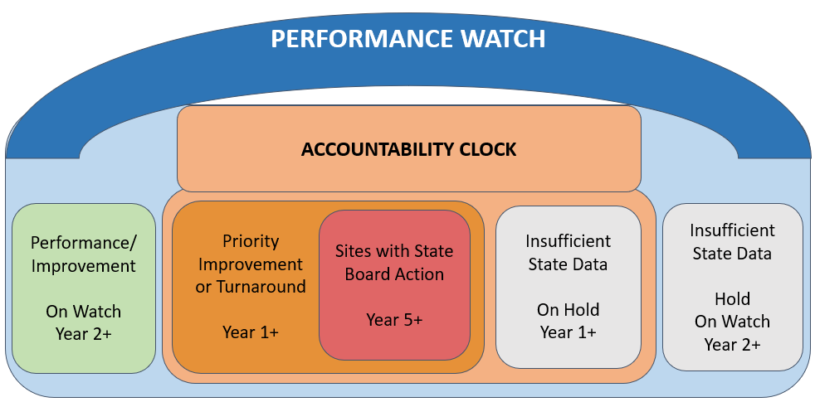

**Resources:** available on the [Performance Watch Expectations](https://www.cde.state.co.us/accountability/performanceturnaround) webpage

# Annual Stakeholder Engagement - Process Expectations

* **Parent Notification Letter**  
  For each school with a plan type of Priority Improvement or Turnaround, the district must notify the families in the school of the school’s plan type, the reason for identification, ways to provide input into the school’s plans (e.g., School Accountability Committee meeting) and notification of the local board’s hearing prior to adopting the school’s plan.
* **Have your board approve your UIP**  
  You will need to have your board approve your UIP before it is publicly posted on or by October 15th, or January 15th (for Year 1 identified schools or if the site is participating in the Request to Reconsider process). If you haven’t yet arranged for time at a board meeting to do this, now is a good time to schedule it.
* **Online UIP Template**

Use the Assurances to note completion of these requirements. If the UIP is due before the local board approval, just include the date of the local board meeting when the UIP is adopted, and then update the UIP in the online system.

**Resource**: [Parent Notification and Public Hearing Requirements (2024-25)](https://www.cde.state.co.us/uip/parent_notification_fact_sheet), includes a sample Parent Notification Letter in English and Spanish) that could be used for both state and federal identification.

**Where to include it:** UIP – Assurances

**Assurances**

|  |  |
| --- | --- |
| **Family Notification and Local Board Adoption** | * **Written notice of the initial plan type was shared with families within 30 calendar days of identification.** * **The SAC met to provide input on the improvement plan prior to the public hearing.** * **A public hearing was held at least 30 calendar days after the date on which the district provided the written notice.** * **The local board reviewed and adopted the plan.** |

# Later on the Clock Requirements

## Year 3 – Community Meeting

**Who:** Schools and Districts entering Year 3 on the clock

**Requirements:** Districts must host a parent and community meetingto provide information and receive input on the school or district’s accountability rating and next steps to improve. It may be a standalone meeting or connected to a District Accountability Committee / School Accountability Committee meeting. CDE assigned Transformation Specialist will provide support to the identified district/school through this process.

**Resource:** [Year 3 Community Meeting Supplement](https://www.cde.state.co.us/accountability/year-3-community-meetings-fact-sheet)

## Year 4 – Identify Pathway Preference

**Who:** Schools and Districts entering Year 4 on the clock

**Requirements:** At Year 4, a CDE Transformation Specialist will support the district and school site in determining the best suited accountability pathway. Sites may engage in the State Review Panel in spring of Year 4, anticipating Year 5 end of clock.

**Resource:** [What to Know at Year 4 of the Accountability Clock](https://www.cde.state.co.us/uip/fact-sheet-year-4-merged-september-final-2020)

## Year 5 – State Board Hearing & Directed Action

**Who:** Schools and Districts at the end of the clock, Year 5

**Requirements:** At Year 5, the school or district participates in a hearing with the State Board of Education. At the hearing, the board must direct a course of action (pathway). Prior to the hearing, the State Review Panel (SRP) will conduct an SRP visit to evaluate the site’s adopted improvement plan, including capacity of the school/district to engage in dramatic change and provide recommendations to the Commissioner and Board of Education on potential actions. The visit typically occurs when sites are at Year 4 on the clock, with the latest visit in the fall of the school year when the current framework rating advances the site to Year 5 on the clock.

**Resources:** Refer to the [State Review Panel](https://www.cde.state.co.us/uip/statereviewpanel) and [Accountability Pathways](https://www.cde.state.co.us/accountability/accountability_clock#AccountabilityPathways) webpages

# 

# Satisfying State Identified Planning Requirements

## 1: Family Engagement Activities

**Who:** All schools with Priority Improvement and/or Turnaround plan types

**Requirement:** Include high leverage action steps to increase parent engagement at the school that are aligned with Family, School and Community Partnering Standards

**Where to include it:**

* UIP – Action Steps – Implementation & Actions (streamlined template) / Action Plans (traditional template)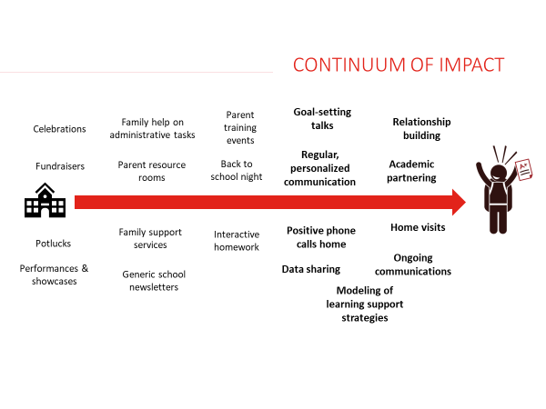

**Resources:**

* [Strategy Guide](https://www.cde.state.co.us/sites/default/files/docs/uip/FSCP_Strategy%20Guide%202.0.pdf). For schools that are interested in making Family, School, and Community Partnerships (FSCP) one of their Major Improvement Strategies, this Strategy Guide outlines the core components and key resources needed for a successful implementation.
* [P-12 Family School and Community Partnerships Framework](https://www.cde.state.co.us/familyengagement/p-12_fscp_framework). Schools and districts who are interested in strengthening their FSCP work can use this framework to audit the current state of their systems and practices, in order to determine priorities for improvement.
* [Promising Partnership Practices](https://www.cde.state.co.us/familyengagement/promising). CDE’s FSCP Office has collected accounts of successful family-school partnership practices from schools and districts throughout Colorado. These provide useful illustrations for schools and districts seeking ideas for how to more effectively engage their families and communities.
* [Six global lessons on how family, school, and community engagement can transform education](https://www.brookings.edu/articles/six-global-lessons-on-how-family-school-and-community-engagement-can-transform-education/) (Brookings Institute, 2024). This report is the result of the participation of hundreds of students, families, school educators, and researchers who dedicated their time and energy to investigating the critical role that families and communities play in ensuring students and schools can flourish.

## 2: Math Acceleration Planning Requirement

**Who:**  Schools with Improvement, Priority Improvement or Turnaround plan type

**What it is:** House Bill 23-1231 passed in April 2023 seeks to improve outcomes in pre-kindergarten through twelfth grade mathematics by putting in place supports to accelerate achievement.

**Where to include it:**

* Data Analysis through Assurances
* Priorities & Targets (streamlined template) / Priority Performance Challenges (traditional template)
* Action Steps – Implementation & Actions (streamlined template) / Action Plans (traditional template)
* Target Setting (traditional template)

**Assurances**

|  |  |
| --- | --- |
| **Data Analysis** | **Math Acceleration assessment performance data from at least the last two school years has been analyzed. Data were disaggregated by grade level, performance levels, and student demographics (e.g., Free & Reduced Lunch, IEP, Multilingual Learners).** |

**Student Performance Priorities / Priority Performance Challenges**

|  |  |
| --- | --- |
| **Rationale for Prioritization** | **The rationale describes performance patterns that led to prioritizing math. If the data analysis does not support prioritizing math, then an explanation is included to document rationale for the school-wide direction.** |

**Targets (Priorities & Targets / Action Plans–Target Setting)**

|  |  |
| --- | --- |
| **Targets for below grade level OR struggling students** | **The plan sets ambitious and attainable target(s) for reducing the number of students who are below grade level expectations or are struggling in math, as measured by local or state assessments.** |

**Action Steps**

|  |  |
| --- | --- |
| **Actions to Address Math** | **The plan includes evidence-based Action Steps that will likely have a meaningful impact for students identified as being below grade level or struggling in math.** |

**Resources:** Refer to the [Supporting Struggling Learners in Mathematics](https://www.cde.state.co.us/comath/strugglinglearners) for more information.

## 3: Early Learning Needs Assessment (ELNA)

**Who:** All K-3 schools with Priority Improvement or Turnaround plans & their districts if also identified PI/T.

**What it is:** The Early Learning Needs Assessment supports schools and districts in analyzing the needs and learning of children from birth through age 8. This process can strengthen relationships between schools, districts and early childhood partners to more accurately identify needs within the community, monitor trends, and inform the implementation of preventative strategies.

**Where to include it:**

* Root Causes & Strategies (Streamlined Template) or Data Narrative–Root Causes (Traditional Template)

**Root Causes**

|  |  |
| --- | --- |
| ***Early Learning Needs Assessment*** | The plan summarizes findings from an [Early Learning Needs Assessment](https://www.cde.state.co.us/early/elna) that meets the minimum requirements and commits to next steps based on those findings. |
| ***Early Learning Needs Assessment for Schools in Turnaround*** | The plan identifies appropriate research-based next steps, based on the findings of an Early Learning Needs Assessment, to improve early childhood programs and partnerships. |

**Instructions for 2024-25:**

* Indicate in your UIP any steps you have taken to assess the needs of and resources available for children eight and under across your community.
* Take advantage of the resources available on the [Improvement Planning and Early Learning website](https://www.cde.state.co.us/early/elna) to learn about and plan this year to conduct and report on an Early Learning Needs Assessment in your 2025-26 UIP.

If you’d like additional information on the ELNA, consult the [Early Learning Needs Assessment Handbook](https://www.cde.state.co.us/early/elnahandbook). For a deeper dive, the [Early Learning Needs Assessment Data Sources Guide](https://www.cde.state.co.us/early/elnadatasourceaguide) contains information on data sources that may be helpful in completing this assessment.

As referenced in the UIP Quality Criteria: the ELNA includes a complete analysis of [early elementary student achievement data](http://www.cde.state.co.us/early/earlychildhoodassessment) → the plan identifies appropriate research-based next steps to improve early childhood programs and partnerships.

## 4: Turnaround Strategies

**Who:** Schools and Districts with Turnaround plan type are required to include a state-required turnaround strategy.

**What it is:** The site’s Improvement Plan must identify a state-required turnaround strategy and articulate an action plan that is aligned to the needs identified in the data analysis.

**Where to include it:** Major Improvement Strategies

**Major Improvement Strategies**

|  |  |
| --- | --- |
| **Turnaround Strategy** | **The plan identifies a state-required turnaround strategy and articulates an action plan that is aligned to the needs identified in the data analysis. (Select from dropdown in the UIP Online System.)** |

**Instructions for 2024-25:**

* Select from dropdown in the UIP Online System.
* Your strategies should be clearly defined and focused enough to be accomplished in the plan period. Your current plan may focus on developing key elements of a larger strategy.

**Turnaround Strategies:**

* Employing a lead turnaround partner
* Reorganizing the oversight and management structure in the district
* Converting to an innovation school or school zone
* Converting to a charter school
* Renegotiating or restructuring a charter contract
* Research-based strategies focused on early learning and development
* Other actions of comparable or greater significance or effect.

For additional information, refer to the [EASI grant application process](https://www.cde.state.co.us/fedprograms/easiapplication) that includes options aligned to these turnaround strategies.

# Reminder - READ Act Requirements

## All Schools Serving K-3

**Requirement 1:** Include data and trends from a READ interim assessment for grades K-3.

**Where to include it:** Data Narrative

**Example of Early Literacy Data in a UIP**

|  |  |  |  |  |
| --- | --- | --- | --- | --- |
| Student Grade | Percent On  Grade Level | | Percent Significantly Below Grade Level (i.e., SRD) | |
|  | *2023* | *2024* | *2023* | *2024* |
| Kindergarten | 56% | 25% | 24% | 44% |
| 1st Grade | 70% | 45% | 20% | 18% |
| 2nd Grade | 75% | 72% | 13% | 10% |
| 3rd Grade | 67% | 55% | 13% | 21% |

**Example Strengths:**

**✔** Data reflects percent of students on grade level and students who are SRD

**✔** Identifies a trend over time

**Requirement 2:** Include specific actions to support students who are identified as having a significant reading deficiency (SRD) and students who are not yet reaching grade level expectations.

**Where to include it:** Strategies (in the Action Plans tab)

|  |  |
| --- | --- |
| **Example** | **Example Strengths** |
| **Implement Early Literacy Instruction**  In order to effectively support Early Literacy, we will implement instructional systems that have coherence and focus on foundational skills. K-3rd classes will have a dedicated daily phonics block that follows the Science of Reading methodology as supported by the CDE Modules, Heggerty curriculum and Orton Gillingham methodology.  Teachers will receive coaching to have a deeper understanding of foundational skills. Success will be measured by decreasing the amount of students significantly below grade level by 15% and increasing the amount of students on grade level by 10% (especially Black, Multilingual/MLL, and Black MLL students).  This aligns to district priorities around Early Literacy and phonics to provide a high-quality literacy program that incorporates research and evidence-based principles for instruction, fosters independence and confidence, and leverages assessment practices that give teachers and leaders actionable feedback on how to best serve the needs of diverse learners across all classrooms. | ✔ Reflects a plan to target the needs of students who are not yet on grade-level  ✔ Scientifically and evidence-based actions |

**Requirement 3:** Set targets to improve reading outcomes for students as measured by a READ interim assessment.

**Where to include it:** *Streamlined Template–*Priorities & Targets or *Traditional Template–*Target Setting (in Action Plans tab)

|  |  |
| --- | --- |
| **Example** | **Example Strengths** |
| **Performance Indicator: Academic Achievement** *Measure/Metric: Reading*  **2023-24:** Students on grade level will increase by 10% as measured by iStation  **2024-25:** Students on grade level will increase by 13% as measured by iStation | ✔ The targets explicitly focus on *increasing* the percentage of students reading on grade level and *decreasing* the percentage of students identified as SRD |
| **Performance Indicator: Academic Achievement** *Measure/Metric: Reading*  **2023-24:** There will be a 15% decrease in students SGBL (*i.e., SRD)* as measured by iStation  **2024-25:** There will be a 15% decrease in students SGBL (*i.e., SRD)* as measured by iStation |

## 

# Capacity-Building Opportunities

## Four Domains for Rapid School Improvement

The Colorado's Framework for Rapid School Improvement Framework helps in understanding research based dimensions of school improvement. The department uses the Four Domains to increase effort to align all supports. Initiative overload? Refer back to the Four Domains for Rapid School Improvement rubrics to assess where your system is at, and where you might focus on next.

**Four Domains Diagnostic Rubrics**

* [School Diagnostic Rubric](https://www.cde.state.co.us/accountability/cde-school-four-domains-diagnostic-rubric-v8)
* [District Diagnostic Rubric](https://www.cde.state.co.us/accountability/districtfourdomainsdiagnosticrubric)

## 

## Implementation Guide

**A strong implementation team can mean the difference between an initiative that persists and gets refined through difficulty and one that gets dropped when challenges arise.** Having a team in place before the implementation begins will help you remain nimble and responsive as the plan progresses and the context evolves.

* **Size:** Small enough to be nimble, but with enough capacity to address implementation issues.
* **Competencies:** Team members should be…
  + deeply invested in the strategy, collaborative, and able to communicate very clearly
  + able to weigh different needs, competing interests, trade-offs
  + decisive and able to act quickly to clear implementation obstacles
* **Supporting the Implementation Team:** You may need to free up capacity of Implementation Team members, so they are able to prioritize strategy implementation. Make sure they also have clear access to leadership so they can get additional support or resources needed to strengthen implementation.

For additional information on Implementation Teams, see the [Implementation Guide](https://www.cde.state.co.us/uip/implementation-guide). Once your site has identified major improvement strategies, browse the current **strategy guides** posted at [this webpage](https://www.cde.state.co.us/uip/strategyguides).

## 

## EASI Grant Support Options

Schools and districts with a Priority Improvement or Turnaround plan type are eligible to apply for school improvement funding through the EASI grant process. For more information, visit the [Empowering Action for School Improvement (EASI) website](https://www.cde.state.co.us/fedprograms/easiapplication) or download the 2023 [EASI Menu of Supports](https://www.cde.state.co.us/fedprograms/easimenuofsupports) (2024 version coming soon). Starting this year, EASI applications are submitted through the online [GAINS](https://colorado.egrantsmanagement.com/default.aspx?ccipSessionKey=638296151290307507) system.