EVALUATION REPORT
SCHOOL YEAR 2018-2019
BY: PETER MARLE, ANALYST ACOUNTABILITY & RESEARCH AURORA PUBLIC SCHOOLS

TABLE OF CONTENTS
- Introduction
  - Program and Goals 2
  - Vision 2
  - Performance Measures 3
- Observations
  - Kenton 4
  - Aurora Hills 5
  - Student Profiles 6
- Assessment 7
  - Pre-participation comparisons 8
  - Behavior and Attendance 9
  - Post-participation comparison 12
- Survey Results 12
- Interview Results 14

Introduction
Program and Goals
For the past 20 years, the Aurora Public Schools (APS) and the City of Aurora (COA) have developed an afterschool partnership model that aligns the curriculum frameworks and grade level content from the school day with out-of-school-time academic and enrichment activities to complement students’ classroom successes and enhance positive youth development. This model is branded the Community Of Many Providing After School Success (COMPASS) Program. The COMPASS Program is recognized as a collaborative partnership that successfully promotes student academic achievement, youth development, and school engagement.

Vision
By working collaboratively, COMPASS will assure every child in Aurora the ongoing opportunity to participate in diverse out-of-school enrichment activities that support academic success and positive youth development.

The COMPASS Program strives to provide academic support and enrichment opportunities that:
- Focus on positive youth development strategies, foster youth engagement and focus on inclusiveness and resiliency to promote a positive identity
- Improve academic performance through a combination of academic and enrichment experiences
- Strengthen community collaboration between all stakeholders for student success
- Provide an opportunity for children to make new friends, learn new skills and explore new interests
Performance Measurements
PM 1 - Core Academic
-60% of all regular attendee students, who received continuous support in small group
literacy support, will attain a median growth percentile of 50 in English Language Arts, as measured by CMAS/PARCC (or other designated state assessment) with a 5% increase of regular attendee students to meet that goal for each of the following 2 years of the grant.
-10% of ELL students will have 1 years growth on WIDA Access Assessment (when
assessment has been re-introduced to the district for use).

PM 2 - Essential Skills/Educational Enrichment
90% of regular attenders will show increased leadership skills and will have an understanding of various cultural traditions, as measured by retrospective survey and focus group/interview questions.

PM 3 - Attendance
Each year of the grant, 90% of regular attenders will have a minimum of 85% Average Daily Attendance during the regular school day.

PM 4 - Family Engagement
In year one, 20% of parents of regular attenders will participate in a counseling session, academic oriented student meetings, and/or culturally responsive activities with an increase of 5% of parents of regular attenders participating in each subsequent year of the grant (25% in year 2, 30% in year 3).
Observations - Kenton
Two independent researchers observed the Compass program in May of 2019 at both Kenton and Aurora Hills. The observation consisted of items related to Student Interactions, Staff Relationship Building, Instructional Strategies, and Activity Content & Structure.
At Kenton, nearly 50 students were present at the time of observation, and they were split in 8 smaller groups throughout the school, with either a Certified Teacher or Specialist interacting with each group. They were working on academics, building reading skills, sports, writing, and using technology. One strength of the program related to Staff Relationship Building – namely that positive behavior management techniques, equitability & inclusiveness, positive affect toward students, attentive listening, and engagement with students were highly evident. Staff were respectful and genuinely interested in what students said and did – one activity centered on compassion and empathy. Activity Structure and Content was another strength: activities were well organized, challenged students, and involved practice or progression of skills. Within Activity Structure and Content, though, it was observed that the activities required little to no analytic thinking. Few opportunities were observed for problem-solving. However, they were planned to engage students and were at the appropriate challenge levels. Student Interactions were rated relatively low, with students being given an opportunity to make meaningful choices not being observed, opportunities for collaboration and taking leadership roles being observed rarely, and students contributing opinions, ideas, and/or concerns moderately often. Students were engaged in the assigned activities, but few of the multiple, age- and need-based activities promoted leadership skills. Instructional Strategies was mixed: although teachers engaged often with the students, other constructive strategies were rarely evident. Academic activities were designed around the instructional needs of the students in each group. Standards-based practice of skills was also observed. The level of supervision, work space, and materials were all appropriate for the activities observed. In addition, the primary activity observed across all activities was skill-building with reading/writing/literacy.
Observations – Aurora Hills
At Aurora Hills, about 25 students were split into 5 groups, led by Certified Teachers. Students were participating in academic activities, dance, and sports – in classrooms and outside on school grounds. The program at Aurora Hills seemed to be more focused on engagement and capacity-building; thus, the observations related to Student Interactions, Staff Relationship Building, Instructional Strategies, and Activity Content & Structure were not rated as high as that of Kenton. In general, Staff Relationship Building was the strongest domain observed, with staff showing positive affect toward and engaging with students (observed as highly evident). Staff were respectful towards students and took an interest in the students and their interests. Rubric items related to Student Interactions (i.e., collaboration, leadership, opportunities to contribute opinions, and make meaningful choices) were observed to be either rarely evident or not evident. The level of student engagement was dependent on the activity – students were compliant and followed directions. Activity Content and Structure rubric items (i.e., well-organized, challenging for students, requiring analytical thinking, and involving practice/progression of skills) were also rarely or not evident. Activities were planned appropriately towards the needs and interests of students, but few extended to problem-solving opportunities. Finally, constructivist Instructional Strategies were mostly observed as not evident – although teachers employing scaffolding techniques was observed to be highly evident within this domain. The design of the groups were not conducive to encourage enhanced and deeper levels of knowledge. Academic activities were mostly skill-building, and they were club-based, related to the interests of the students. The level of supervision, workspace, and materials were all appropriate for the activities observed.
Student Profiles
A total of 90 students (17.51% of the total number of students enrolled) from Kenton Elementary School, and 135 students (16.50%) from Aurora Hills Middle School participated in Compass programming in the 2018-19 school year. Of the students who participated in Compass, 54% (n = 49) at Kenton and 12% (n = 16) at Aurora Hills regularly participated in the programming offered.
Further breakdown of the percentage of students by disaggregated demographic groups is provided in Table 1. In the table, the total number of students within each disaggregated group (i.e., Gender, ELL Status, Race / Ethnicity, and IEP Status) is provided, along with the percentage of students within that group comparison. In effect, each separate grouping will add to 100% -- for example, at Kenton, the percent of male (56%) and female students (44%) involved in Compass add to 100%. The percentages of students in each group can then be compared for each school (i.e., Compass vs. Not Compass) to assess if there are different proportions of students attending the programming.
In terms of gender and IEP status, there was little difference between Compass and Non-Compass students for each school. However, there were differences in the percentage of students within ELL status and Race / Ethnicity groups. For Kenton, and not unexpectedly, more students who were NEP / LEP attended Compass programming. For Aurora Hills, though, a greater percentage of students classified as Not ELL were involved in Compass. Concurrently, less Hispanic students and more White students participated in Compass at Aurora Hills.

Table 1. Compass Enrollment, Disaggregated Groups.
 |  | Kenton Elementary |  | Aurora Hills
 |  | Compass  n (Pct.) | Not Compass  n (Pct.) | Compass  n (Pct.) | Not Compass  n (Pct.)
Gender
 | Male | 40 (44%) | 189 (45%) | 65 (48%) | 314 (46%)
 | Female | 50 (56%) | 235 (55%) | 70 (52%) | 369 (54%)
ELL Status
 | NEP / LEP | 67 (74%) | 261 (62%) | 39 (29%) | 202 (30%)
 | FEP | 2 (2%) | 24 (6%) | 19 (14%) | 162 (24%)
 | Not ELL | 21 (23%) | 133 (31%) | 76 (56%) | 288 (42%)
 | FELL / PHLOTE | 0 (0%) | 6 (1%) | 1 (1%) | 31 (5%)
Race / Ethnicity
 | American Indian | 0 (0%) | 1 (0%) | 2 (1%) | 7 (1%)
 | Asian | 9 (10%) | 20 (5%) | 6 (4%) | 25 (4%)
 | Black / African Amer. | 13 (14%) | 54 (13%) | 31 (23%) | 154 (23%)
 | Hispanic | 66 (73%) | 312 (74%) | 57 (42%) | 402 (59%)
 | Native Hawaiian/Pac. Isl. | 0 (0%) | 1 (0%) | 0 (0%) | 8 (1%)
 | White | 0 (0%) | 21 (5%) | 30 (22%) | 45 (7%)
 | 2+ Races Indicated | 2 (2%) | 15 (4%) | 9 (7%) | 42 (6%)
IEP Status
 | On an IEP | 15 (17%) | 62 (15%) | 19 (14%) | 106 (16%)
 | Not on an IEP | 75 (83%) | 362 (85%) | 116 (86%) | 577 (84%)
Note. Percentages are computed within the respective disaggregated group per each school.
Grade-level representation was also assessed. In order to see the overall representation of Compass participation across grade levels, Figure 1 illustrates the percentage of students within each grade level who were involved in Compass programming. In general (for both schools), a decreasing proportion of students participate in Compass in later grades.

Figure 1. Percentage of students within each grade level who were involved in Compass programming in 2018-19.

Assessment
Pre-participation comparisons
To assess if there were differences in groups prior to participation in Compass programming, CMAS ELA achievement and growth scores from 2017-18 were analyzed. Overall, Compass students (M = 718.05, SD = 33.55) were not significantly different than Non-Compass students (M = 715.21, SD = 31.88) regarding CMAS English Language Arts achievement scores, t(518) = 0.71, p = .476. For Aurora Hills, Compass students (M = 724.57, SD = 34.04) tended to score slightly higher than Non-Compass students (M = 715.85, SD = 32.49), although the difference was not statistically significant, t(395) = 1.85, p = .065. For Kenton, Compass students (M = 699.80, SD = 24.74) tended to score lower than Non-Compass students (M = 713.09, SD = 29.84), although, again, this difference did not achieve statistical significance, t(121) = -1.87, p = .064.
CMAS Growth was also assessed. Overall, Compass students (M = 50.90, SD = 32.00) scored similarly, regarding their average growth percentiles, compared to Non-Compass students (M = 45.99, SD = 28.58), t(422) = 1.20, p = .230. For Aurora Hills, Compass students (M = 52.13, SD = 32.62), again, scored similarly compared to. Non-Compass students (M = 47.18, SD = 29.06), t(369) = 1.12, p = .264. The same was true for Kenton: Compass students’ (M = 41.71, SD = 27.32) growth percentiles was similar to Non-Compass students’ growth (M = 37.76, SD = 23.67), t(51) = 0.40, p = .688.
Thus, regarding both achievement and growth on the Colorado Measures of Academic Success, English Language Arts assessment, students who enrolled in Compass programming for the 2018-19 school year were not statistically different from their peers who did not participate in Compass.
Behavior and Attendance
Behavior and attendance throughout the school year were also monitored for the two schools, and comparisons for Compass versus Non-Compass students follow. Although these data are attributed to end-of-year referral and attendance rates, it should be noted that the results cannot ascertain student-level change resultant of Compass participation. Rather, the results report on the differences noted between the two groups of students. Although one possibility is that participation in Compass programming may increase attendance rates and inhibit negative behaviors that result in disciplinary referrals, there are other possibilities that this paper cannot rule out. Nevertheless, students who participated in Compass had better attendance rates and less disciplinary referrals than their peers who were not involved in Compass programming.
Regarding attendance rates, students enrolled in Compass had slightly better (although non-significant) attendance rates (M = 94.97%, SD = 6.79%) than students not enrolled in Compass (M = 93.70%, SD = 7.90%); however, students who regularly attended Compass had significantly higher attendance rates than both of the former groups (M = 97.47%, SD = 3.87%), F(2, 1329) = 8.88, p < .001. Additionally, 48 of the 49 (98%) regular Compass students had an attendance rate above 85% at Kenton, and all 16 students (100%) who were regular attendees at Aurora Hills had attendance rates above 85%.

Figure 2. Attendance rates by Compass enrollment type and school.

Regarding behavior (see Figure 2), overall, zero students who were regular Compass attendees had behavioral referrals (percentages = total number of referrals for a group / total number of students in the group). For students who attended Compass programming, but not regularly, the percentage of behavioral referrals increased to about 14% -- this is in comparison to the percentage of referrals for students not involved in Compass (23%). Specifically, at Aurora Hills, no students who regularly attended Compass programming had behavioral referrals. The percentage increased to 17% regarding students who attended Compass programming (but not regularly), and the percentage of referrals at Aurora Hills for students not involved in Compass was 33%. At Kenton, again, no students who regularly attended Compass programming had behavioral referrals. The percentage increased to 5% regarding students who attended Compass programming (but not regularly), and the percentage of referrals for students not involved in Compass was 8%.

Figure 3. Behavior referral percentages, comparing Compass enrollment types for Kenton and Aurora Hills.

Post-Participation Comparison
2018-19 CMAS ELA achievement and growth will be compiled as an addendum to this report after they are made available.

Survey Results
Students were given the chance to complete a survey that consisted of items related to openness to other cultures (Culture subscale; 4 items) and Leadership Skills (6 items) – with all items anchored on a 4-point agreement Likert scale. In addition, the survey was slightly different for the two different schools. Whereas Kenton students received a post-only survey, Aurora Hills students received a retrospective-pre / post survey (e.g., “Prior to Compass, …” vs. “After Compass, …”). Survey subscale and item details are shown in Figures 4 – 6) For the Kenton students who completed the survey (n = 22), 77% responded agreeably to the items on the Culture subscale and 72% responded agreeably to items on the Leadership Skills subscale. The most agreed-upon items for Kenton students (per each subscale) were:
- “Compass helped me to be friends with others who look or act different than me.” (Culture subscale; 95% agreement rate)
- “Compass helped me to think before I act” (Leadership Skills subscale; 80% agreement rate)
For Aurora Hills students who completed the survey (n = 11), the rate of agreement slightly increased, comparing retrospective pre items to the post items on the Culture subscale – from 68% to 70% agreement. However, for the Leadership Skills subscale, the agreement rate decreased from 52% to 43%. Nevertheless, the most agreed-upon post items per each subscale for Aurora Hills students were:
- “After Compass, I like to be friends with others who look or act different than me.” (Culture subscale; 78% agreement rate)
- “After Compass, I am able to easily talk about my ideas with others.” (Leadership Skills subscale; 67% agreement rate)
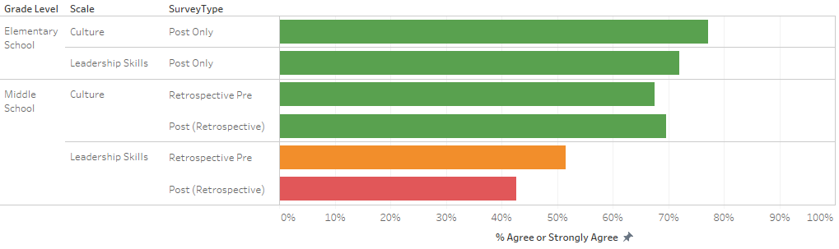
Figure 4. Overall agreement rates on Culture and Leadership Skills subscales for Kenton and Aurora Hills.
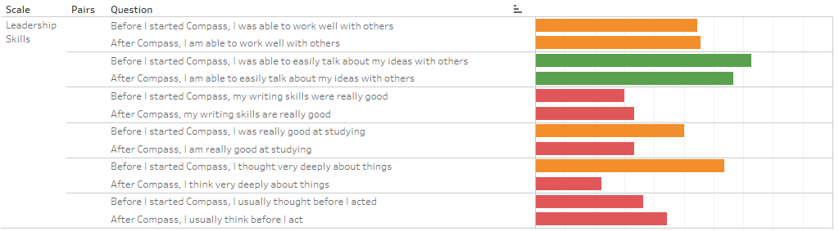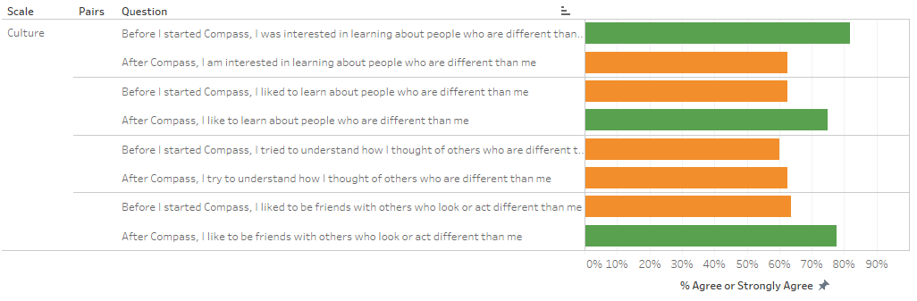
Figure 5. Survey item agreement rates for Aurora Hills student survey.
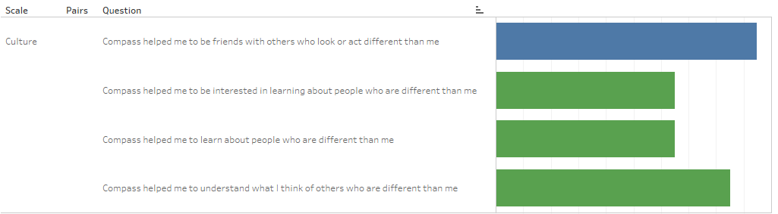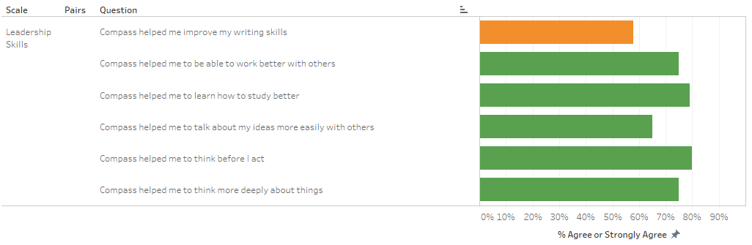
Figure 6. Survey item agreement rates for Kenton student survey.

Interview Results
We conducted a focus interview toward the end of the school year with regular attendees at Aurora Hills to garner additional insight into the program. Specifically, we asked six questions:
- Why did you first get involved in Compass?
- How has Compass helped you academically?
- Has Compass helped you become more motivated to learn? Why or why not?
- What else has your involvement in Compass helped you with?
- What else do you think Compass should help you with, but currently does not (or does little)?
- Please let us know if there is anything else you would like to say about the Compass Program.
In general, students said that they became involved in Compass because they either thought it would be fun and/or help their academics. For the second question, students noted that the program has helped their math, English, and social studies skills, and it has improved their attendance. Students also reported that the program has helped them to finish their work, become more attentive, and meet new teachers. Responding to the fourth question, students noted that they come to school more often, have better study habits, are more open-minded, and have been able to use technology more.
Students also voiced their opinion as to how Compass can be improved, stating that it should help them more academically and have more interactive classes.

