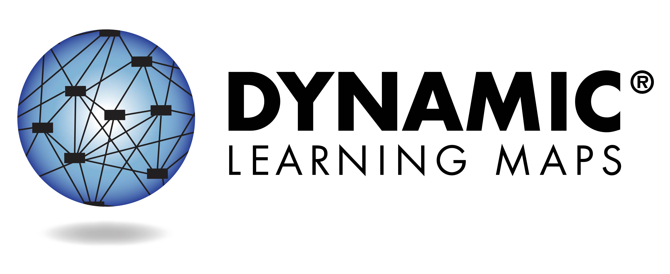

What is the Dynamic Learning Maps® (DLM®) Assessment?
As part of the Colorado Alternate Assessment (CoAlt), your child’s teacher used the DLM® Alternate Assessment System to test academic progress in English language arts (reading and writing) and math. This assessment is designed for students with many types of significant cognitive disabilities. The CoAlt is a completely individualized test designed so students can show what they know and can do. The assessment is given in short sections called testlets so your child does not become too tired or stressed.

Your child will receive an Individual Student Score Report for each subject tested. This report indicates the skills your child demonstrated during the assessment.

Understanding Your Child’s Individual Student Score Report

Colorado Alternate Assessment
English Language Arts & Math
2018-2019

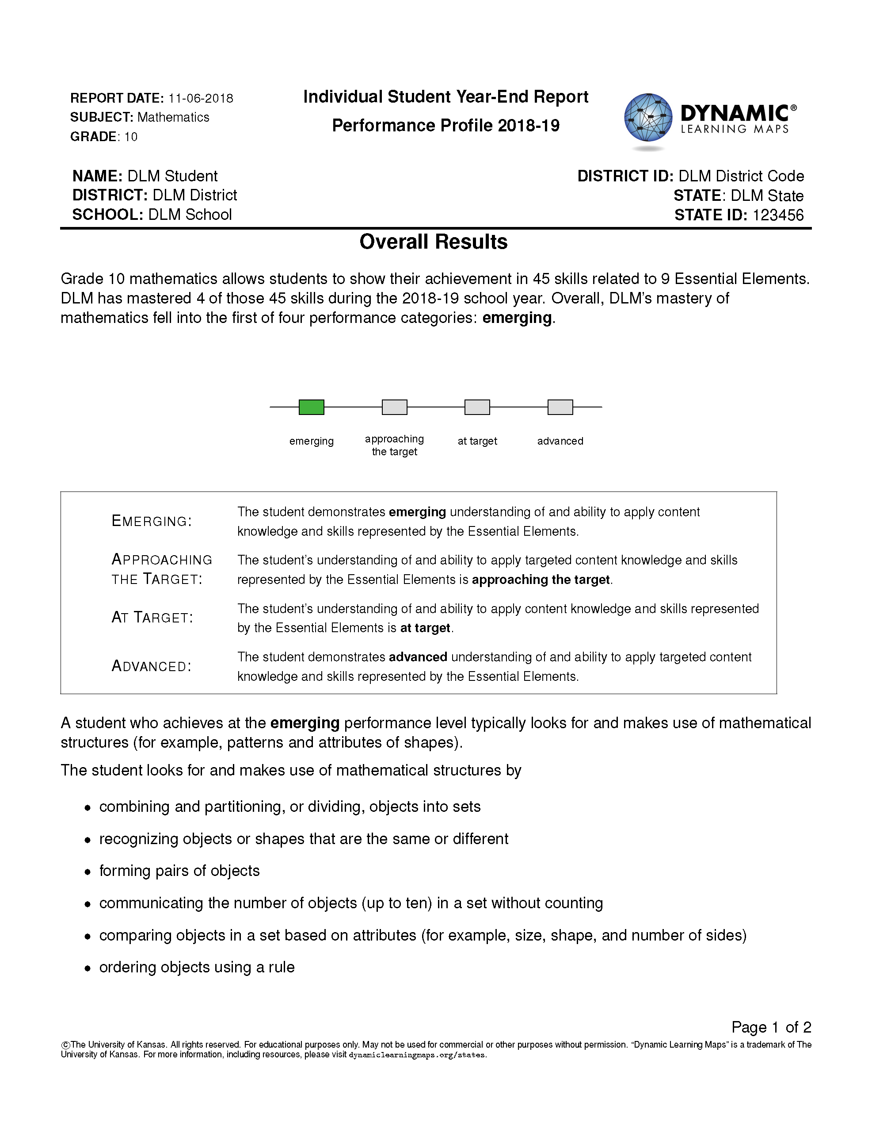
Overview
Each Individual Student Score Report contains information about your child’s performance for one subject. This report includes the Performance Profile.

Performance Profile
The first part of the Performance Profile describes your child’s overall performance based on Essential Elements, which are the alternate achievement standards for this subject. The performance levels are:
- emerging
- approaching the target
- at target
- advanced
“At target” means your child has met the alternate achievement standards in this subject at your child’s grade level.
This part of the report also lists examples of skills mastered by students at your child’s performance level. Your child may or may not demonstrate all of these skills.
Please see your child’s Individual Score Report for specific information regarding your child’s performance.
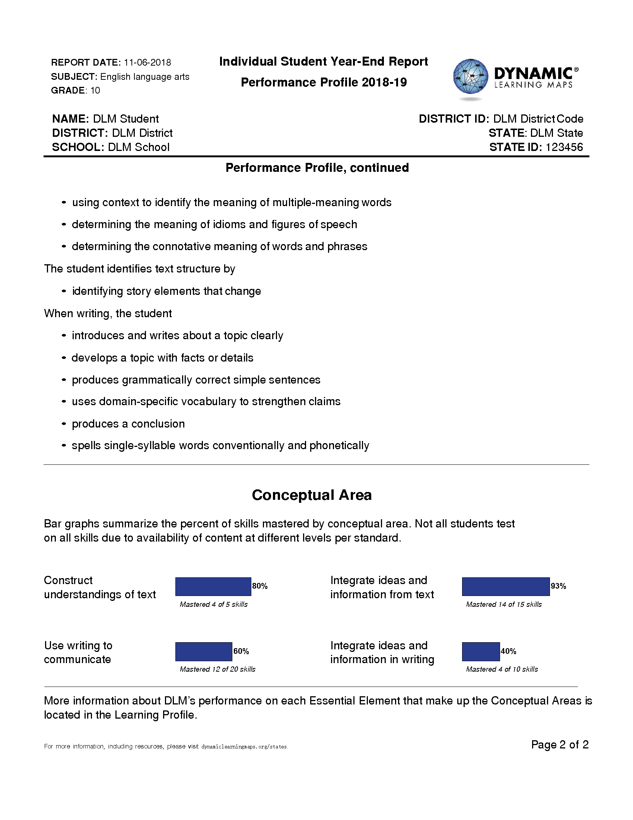
The second part of the Performance Profile describes the percentage of skills your child demonstrated on related academic skills. If the number of skills mastered exceeds the total number of skills, your child was tested on (and mastered) more skills than necessary.
As is the case with any test result, your child's ability to demonstrate certain skills may vary from one testing attempt to another. Please keep in mind that the skills demonstrated during this assessment provide only one piece of evidence of what your child knows and can do.

